Project Design Phase-II Technology Stack (Architecture & Stack)

|  |  |
| --- | --- |
| Date | 30 October 2023 |
| Team ID | 153FEE77E2BD77F95DB47FD6C0047366 |
| Project Name | Unearthing Trends from LinkedIn Influencers |
| Maximum Marks | 4 Marks |

Technical Architecture:

The Deliverable shall include the architectural diagram as below and the information as per the table1 & table 2

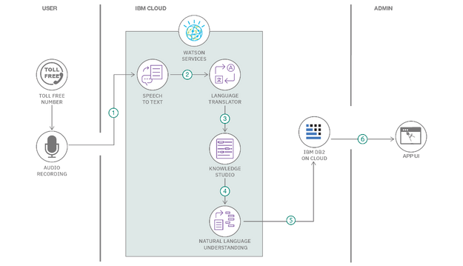

Guidelines:

1. Include all the processes (As an application logic / Technology Block)
2. Provide infrastructural demarcation (Local / Cloud)
3. Indicate external interfaces (third party API’s etc.)
4. Indicate Data Storage components / services
5. Indicate interface to machine learning models (if applicable)

Table-1 : Components & Technologies:

|  |  |  |  |
| --- | --- | --- | --- |
| S.No | Component | Description | Technology |
| 1. | Connection Count | The number of connections or followers you  have. | data from LinkedIn profiles,posts etc. |
| 2. | Target Audience | Data on likes, comments, shares, and views on  your posts and articles. | Web scraping tools or custom scripts |
| 3. | Influencer Selection | The number of people following your LinkedIn | that can track mentions with LinkedIn |
| 4. | Content Strategy | Information about who has viewed your profile. | NLP technology can help analyze |
| 5. | Content Creation | The number of people who have seen your posts | Tools like Tableau or Power BI |
| 6. | Legal and Compliance | Data on the skills others endorse you for profile | Tools like Hootsuite, Buffer, or Sprout |
| 7. | Connection Growth | How your number of connections has changed | Several tools, such as Traack etc |
| 8. | Budget and Compensation | messaging you may track the response rates. | Tools like Google Workspace, Dropbox, |
| 9. | Content Click-Through Rates: | If you're sharing external content | Object Recognition Model, etc. |
| 10. | Recommendation | recommendations you receive. | LinkedIn and other social media |
| 11. | Influence score | influence score based on various engagement  metrics and interactions. | Slack can facilitate content influencer |

Table-2: Application Characteristics:

|  |  |  |  |
| --- | --- | --- | --- |
| S.No Ch | aracteristics | Description | Technology |
| 1. | Expertise and Knowledge | Influencers on LinkedIn are known expertise | graphic design software |
| 2.  3. | Thought Leadership | LinkedIn influencers are regarded | LinkedIn. Examples include Hootsuite,  Buffer, and Sprout Social. |
|  | Consistency | Consistency is a hallmark of LinkedIn influencers) | They might use tools like Feedly,  Pocket, or content aggregators. |

|  |  |  |  |
| --- | --- | --- | --- |
| S.No | Characteristics | Description | Technology |
| 4. | Authenticity | Authenticity is highly valued. | Technology used |
| 5. | Adaptability | They stay up-to-date with industry trends and  adapt to changes | Technology used |